# OS Assignment 2

## Question 1 – Readme

*Meenakshi Madhu – B180390CS*

P1 = main process - reads an array of size 5

P2 = first child B - calculates avg, std deviation

P3 = second child C - analyses temperatures with avg, std deviation; categorizes locations

P1 - actuates temperature

***IPC Using Unnamed Pipe:***

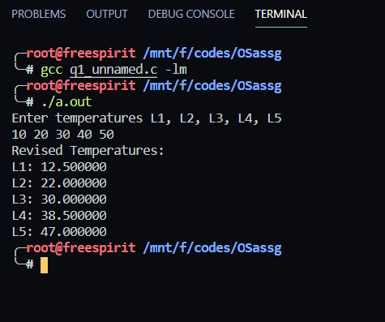

***IPC Using Named Pipe:***

